NAME-AMAN JAIN
ASSIGNMENT LINUX LAB LEVEL 1

1).
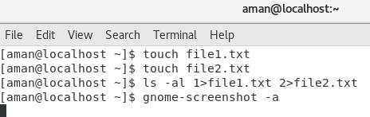

2).
Ctrl+C: Interrupt (kill) the current foreground process running in in the terminal. This sends the SIGINT signal to the process, which is technically just a request—most processes will honor it, but some may ignore it.

3). chmod +x on a file (your script) only means, that you'll make it executable. Right click on your script and chose Properties -> Permissions -> Allow executing file as program, leaves you with the exact same result as the command in terminal.

4). The first number is the Owner permission, the second number is the Group Permission and the 3rd number is the World permission.
a read permission is given the value of 4, a write permission is given a value of 2 and an execute permission is given a value of 1.
7 = 4 + 2 + 1 = r-w-x
5 = 4 + 0 + 1 = r-x
0 = 0 + 0 + 0 = - - -
The total permission set is rwxr-x- - -
5). For most directories (750) - Only root can rwx directory - www-data can only read and execute directory - no public/world bits set
6).
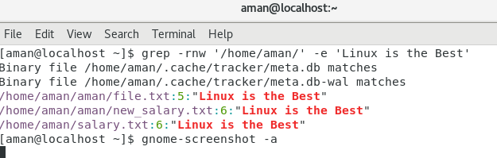

7). Yes,free memory exist on linux.
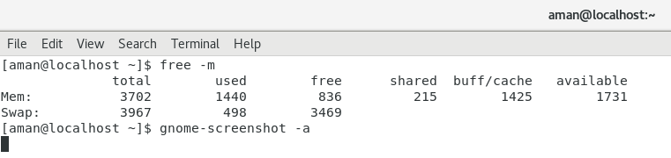
8).
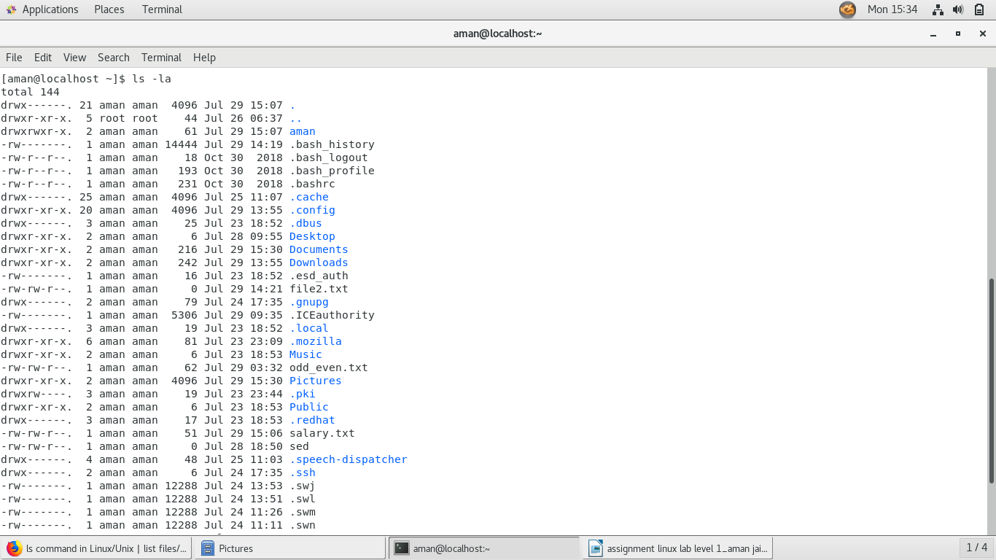
9).
wc -l : Prints the number of lines in a file
wc -w : prints the number of words in a file
wc -m : prints the count of characters from a file
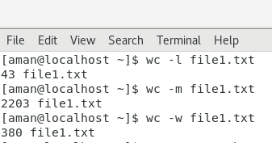

10).
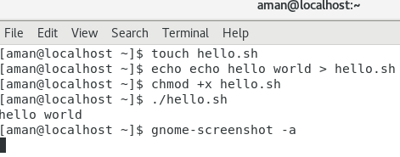

11).
13).
Restart your computer.
- Press E at the Grub menu. ...
- Scroll to the line that begins with LINUX /boot . ...
- Move the cursor to the end of the line. ...
- Type init=/bin/bash after ro . ...
- Press Ctrl + X . ...
- Type mount –o remount,rw / at the prompt and press ↵ Enter .
15).
(date ; ps -ef | awk '{print $1}' | sort | uniq | wc -l ) >> Activity.log
result - Tue Jul 30 00:01:55 IST 2019
15

16).
1. diff -r dir1 dir2 shows which files are only in dir1 and those only in dir2 and also the changes of the files present in both directories if any.
2. diff -r dir1 dir2 | grep dir1 shows which files are only in dir1
3. awk to print only filename.

17).
myvar=hello
my variable is equal to hello
export myvar=hello
it can export shell variables to other with export command

18).
Files type:-
- Regular file(-)
- Directory files(d)
Special files
- Block file(b)
- Character device file(c)
- Named pipe file or just a pipe file(p)
- Symbolic link file(l)
- Socket file(s)
19).
A hard link then just creates another file with a link to the same underlying inode.The inode is only deleted (or deletable/over-writable) when all links to the inode have been deleted. A symbolic link is a link to another name in the file system. Once a hard link has been made the link is to the inode.
Deleting source file will also delete hard link
When you delete ( rm ) a link the counter is decremented (reduced) by one. If the link counter reaches 0 the filesystem removes the inode and marks the space as available for use. In short, as long as you do not delete the last link the file will remain.
20). The & makes the command run in the background.
If a command is terminated by the control operator &, the shell executes the command in the background in a subshell. The shell does not wait for the command to finish, and the return status is 0.
21).
tee
tee, in rough analogy with a plumber's tee fitting, allows us to save a file in the middle of the pipeline and keep going. In this case, the output of sort is both saved as tmp.txt and passed through the pipe to wc -l, which counts the lines of the file.

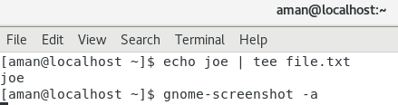

Awk
The key point about awk is, it works line by line. A typical awk construction is:
cat file.txt | awk '{ print }'
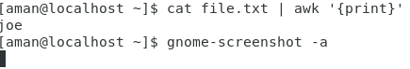

tr
tr stands for translate and it's a utility for replacing characters in text. For example, to replace a period with a newline
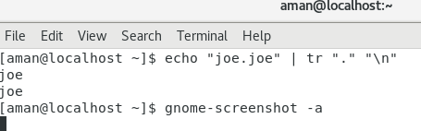

cut
cut cuts one or more columns from a file, and delimits on tab by default.
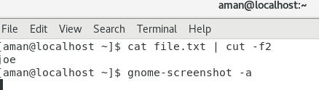

Tac
Tac is practically the reverse version of cat command (also spelled backwards) which prints each line of a file starting from the bottom line and finishing on the top line to your machine standard output.
tac file-all.txt

curl
The curl command transfers data to or from a network server, using one of the supported protocols (HTTP, HTTPS, FTP, FTPS, SCP, SFTP, TFTP, DICT, TELNET, LDAP or FILE). It is designed to work without user interaction, so it is ideal for use in a shell script.
curl [options] [URL...]

wget
Wget command is a Linux command line utility that helps us to download the files from the web. We can download the files from web servers using HTTP, HTTPS and FTP protocols. We can use wget in scripts and cronjobs. Wget is a non-interactive program so that it will run in the background.
wget -i filename

watch
If you prefix a command with watch, it will repeat every 2.0 seconds and you can monitor it. For instance, if a file in /some/directory is growing, and you want to monitor the directory's size
$ watch ls -hl /some/directory

head and tail
head and tail print the first or last n lines of a file, where n is 10 by default.
